**Text moderation**

**WORKING WITH THE OPENAI API**

# James Chapman

Curriculum Manager, DataCamp

**Going beyond text completions...**

**Completions** → generate new text output using text prompt

Beyond completions:

Text moderation

Audio transcription and translation

Combining models together

# Text moderation



Identifying inappropriate content

Traditionally,

Moderators flag content by-hand

Time-consuming

**Keyword pattern matching**  Lacks nuance and understanding of context

# Violation categories



Identify violations of terms or use

Differentiate violation type by category Violence

Hate Speech

1 https://openai.com/policies/usage-policies 2 https://platform.openai.com/docs/guides/moderation/overview

# Creating a moderations request

from

openai

import

OpenAI

client = OpenAI(api_key=

"ENTER API KEY"

)

response = client.moderations.create(

model=

"text-moderation-latest"

,

input

=

"I could kill for a hamburger."

)

# Interpreting the results

print

(

response.model_dump

())

categories { 'model': 'text-moderation-006','id': 'modr-8S80XeaVqvs4mmbufDBP9gTAmEGXP', true / false indicator of category 'results': [{'categories': {'harassment': False, violation 'harassment_threatening': False, 'hate': False,

'hate_threatening': False,

category_scores ...},

'category_scores': {'harassment': 2.775940447463654e-05,

Confidence of a violation 'harassment_threatening': 1.3526056363843963e-06,

'hate': 2.733528674525587e-07,

'hate_threatening': 4.930571506633896e-08,

flagged ...},

'flagged': False}] true / false indicator of a violation }

# Interpreting the category scores

print

(

response.results

[

0

]

.category_scores

)

CategoryScores(harassment=2.775940447463654e-05,

harassment_threatening=1.3526056363843963e-06,

hate=2.733528674525587e-07,

hate_threatening=4.930571506633896e-08,

...,

violence=0.0500854030251503,

...)

Larger numbers → greater certainty of violation

Numbers ≠ probabilities

# Considerations for implementing moderation

CategoryScores(harassment=2.775940447463654e-05, harassment_threatening=1.3526056363843963e-06, hate=2.733528674525587e-07,

hate_threatening=4.930571506633896e-08,

..., violence=0.0500854030251503, ...)

Determine appropriate thresholds for each use case

Stricter thresholds may result in fewer false negatives

More lenient thresholds may result in fewer false positives

**Let's practice!**

**WORKING WITH THE OPENAI API**

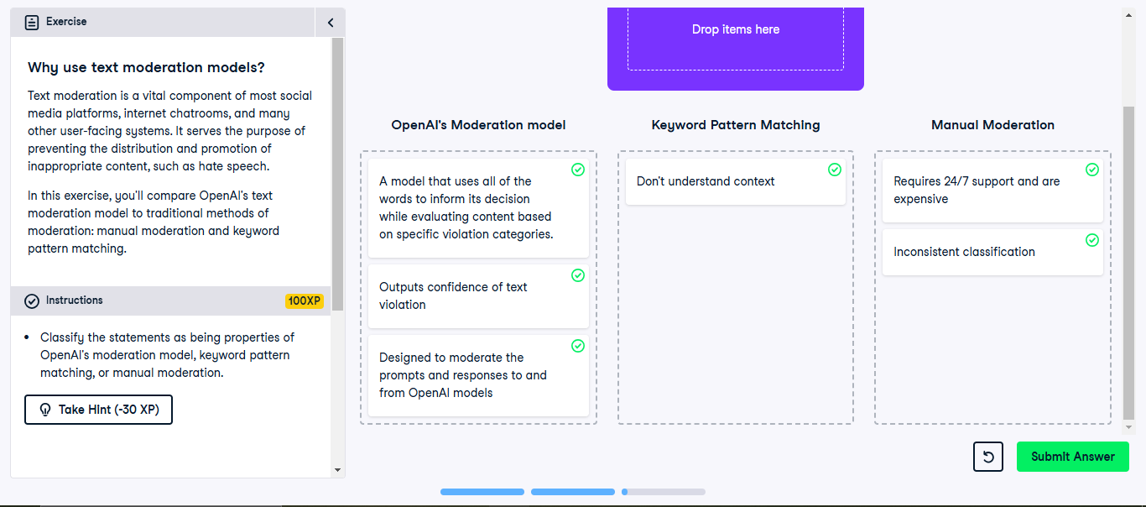

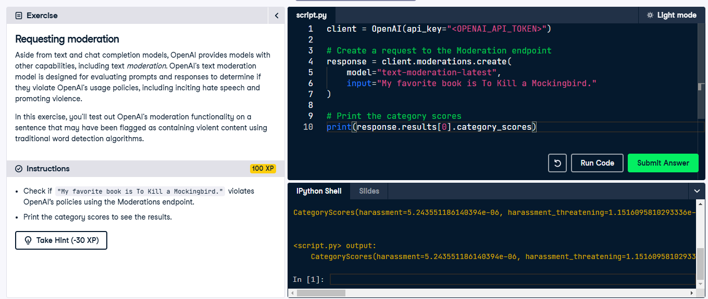

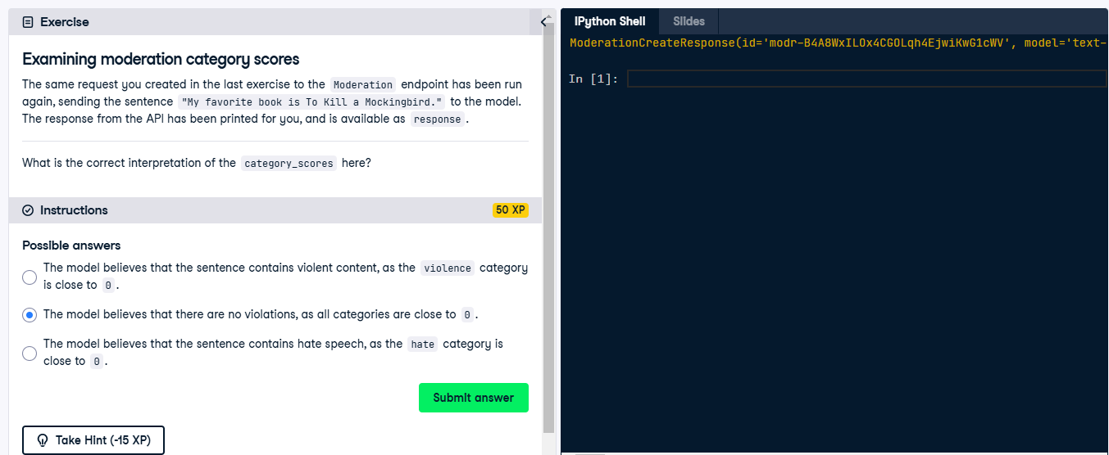

**Speech-to-Text**

**Transcription with Whisper**

**WORKING WITH THE OPENAI API**

## James Chapman

Curriculum Manager, DataCamp

# OpenAI's Whisper

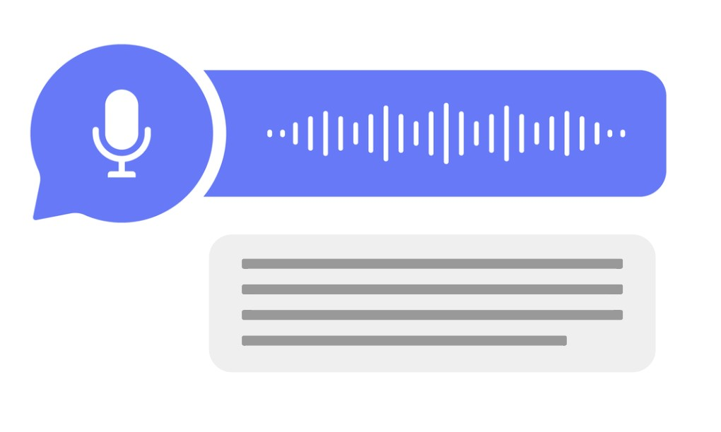

**Speech-to-text** capabilities:

Transcribe audio

Translate and transcribe audio into English

Supports mp3 , mp4 , mpeg , mpga , m4a , wav , and webm (25 MB limit)

Meeting transcripts

Video captions

# Loading audio files

**Example**: transcribe meeting_recording.mp3

audio_file =

open

(

"meeting_recording.mp3"

,

"rb"

)

If the file is located in a different directory audio_file = open("path/to/file/meeting_recording.mp3", "rb")

# Making a request

Audio endpoint

audio_file=

open

(

"meeting_recording.mp3"

,

"rb"

)

response = client.audio.transcriptions.create(model=

"whisper-1"

, file=audio_file)

print

(

response

)

Transcription(text="Welcome everyone to the June product monthly. We'll get started in...)

# The transcript

print

(

response.text

)

Welcome everyone to the June product monthly. We'll get started in just a minute. Alright, let's get started. Today's agenda will start with a spotlight from Chris on the new mobile user onboarding flow, then we'll review how we're tracking on our quarterly targets, and finally, we'll finish with another spotlight from Katie who will discuss the upcoming branding updates...

**Don't use sensitive or confidential recordings**

# Transcribing non-English languages

Afrikaans, Arabic, Armenian, Azerbaijani, Belarusian, Bosnian, Bulgarian, Catalan, Chinese,

Croatian, Czech, Danish, Dutch, English, Estonian, Finnish, French, Galician, German, Greek,

Hebrew, Hindi, Hungarian, Icelandic, Indonesian, Italian, Japanese, Kannada, Kazakh, Korean,

Latvian, Lithuanian, Macedonian, Malay, Marathi, Maori, Nepali, Norwegian, Persian, Polish, Portuguese, Romanian, Russian, Serbian, Slovak, Slovenian, Spanish, Swahili, Swedish, Tagalog, Tamil, Thai, Turkish, Ukrainian, Urdu, Vietnamese, and Welsh.

1. open() audio file
2. Make a transcriptions request to the Audio endpoint
3. Extract text from the response

**Let's practice!**

**WORKING WITH THE OPENAI API**

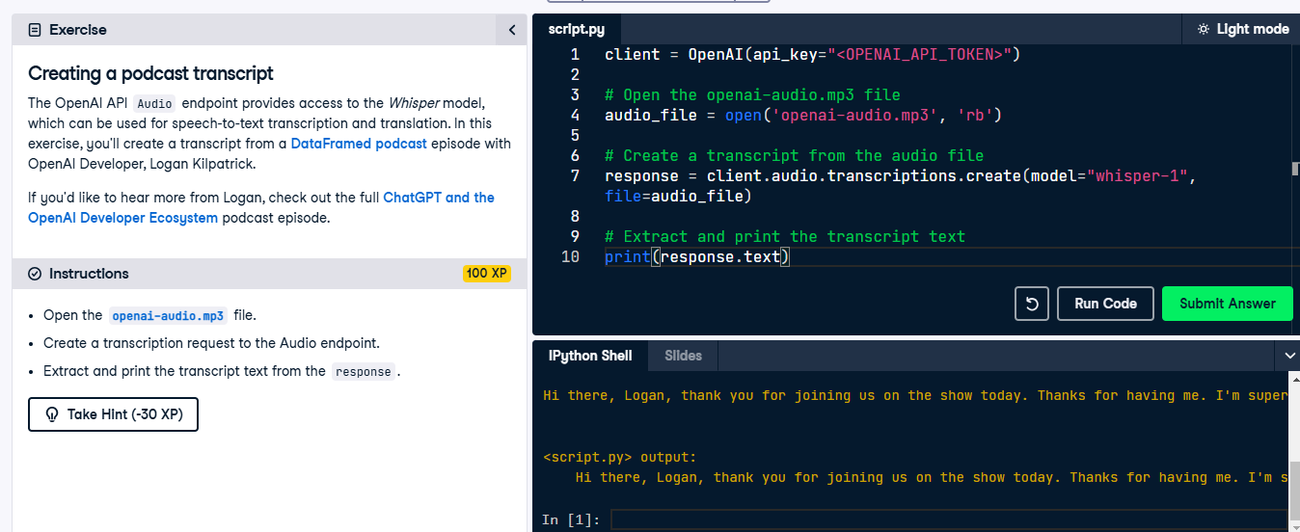

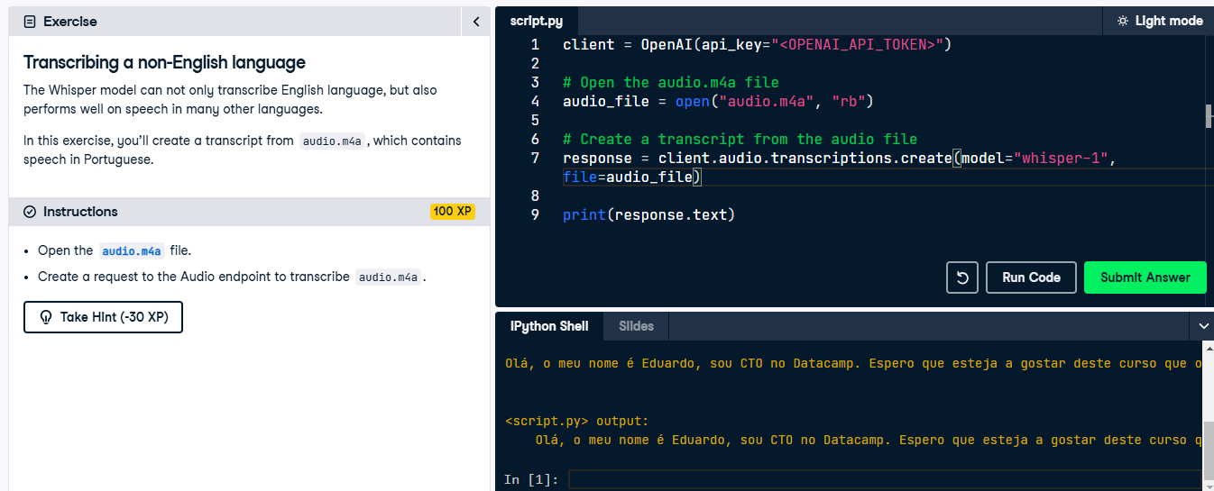

**Speech Translation with Whisper**

**WORKING WITH THE OPENAI API**

## James Chapman

Curriculum Manager, DataCamp

# Whisper's translation capabilities



Translate and transcribe audio

Currently limited to English transcripts

Supports mp3 , mp4 , mpeg , mpga , m4a , wav , and webm (25 MB limit)

# Translating audio

audio_file =

open

(

"non_english_audio.m4a"

,

"rb"

)

response = client.audio.translations.create(model=

"whisper-1"

, file=audio_file)

print

(

response.text

)

The search volume for keywords like A I has increased rapidly since the launch of

Cha GTP.

Performance can vary wildly, depending on: Audio quality

Audio language

Model's knowledge of the subject matter

# Bringing prompts into the mix

Can provide prompt to the model (optional)

Improve response quality by:

Providing an example of desired style

Provide additional context about transcript

**Example**: Retaining filler words prompt="Ok, ummm... this is what we should do, like, to uhhh... increase revenue."

**Example**: Provide context

prompt=

"A discussion on how to increase revenue."

# Adding in a prompt

audio_file = open("non_english_audio.m4a", "rb") prompt = "The transcript is about AI trends and ChatGPT."

response = client.audio.translations.create(model="whisper-1", file=audio_file, prompt=prompt)

print(response.text)

The search volume for keywords like AI has increased rapidly since the launch of

ChatGPT.

**Let's practice!**

**WORKING WITH THE OPENAI API**

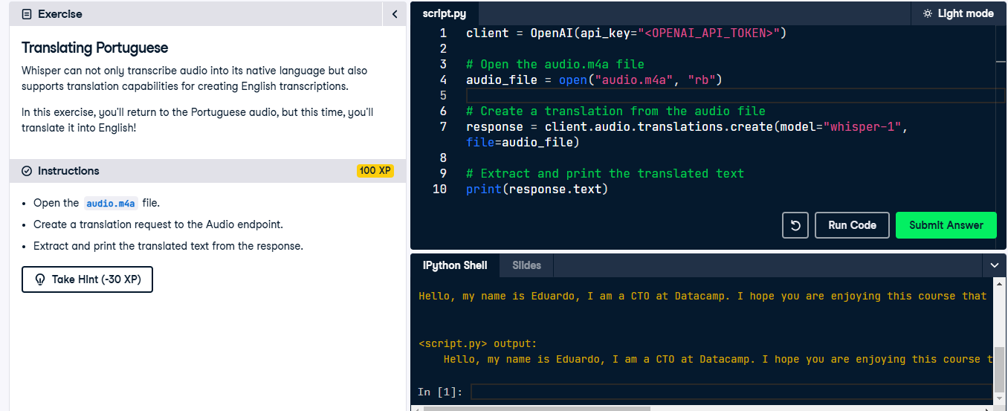

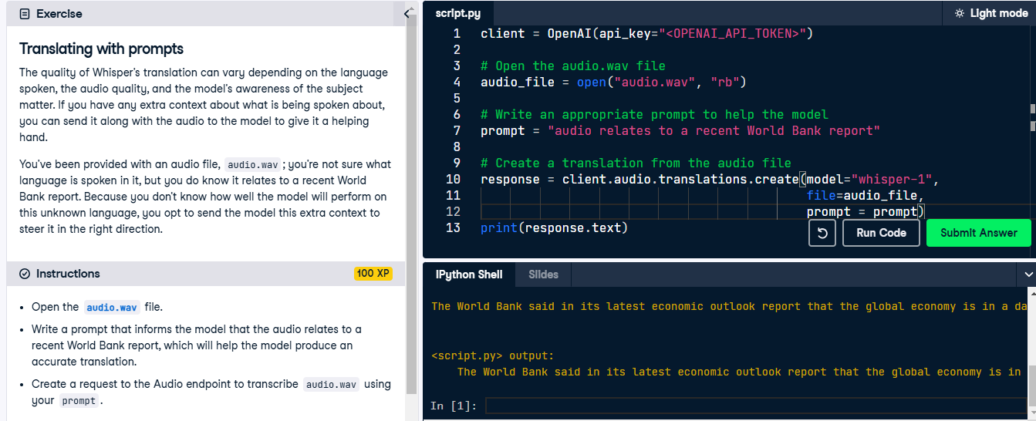

**Combining models**

**WORKING WITH THE OPENAI API**

## James Chapman

Curriculum Manager, DataCamp

# Combining models

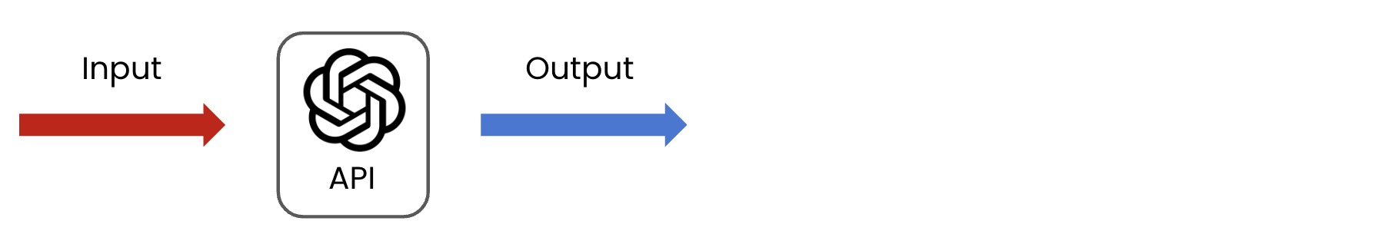

# Combining models

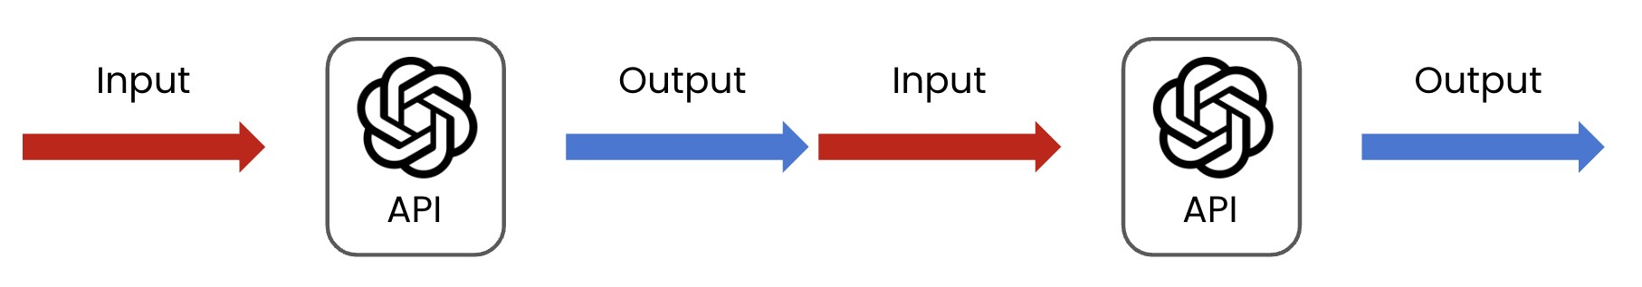

**Chaining**: Feeding output from one model into another

Can use the same model multiple times

**Example**: validating original response

Or different models

**Example**: summarizing meeting recordings

# Example: Extracting meeting attendees

audio_file =

open

(

"meeting_recording.mp4"

,

"rb"

)

audio_response = client.audio.transcriptions.create(model=

"whisper-1"

, file=audio_file)

transcript = audio_response.text

prompt =

"Extract the attendee names from the start of this meeting transcript: "

+ transcript

chat_response = client.chat.completions.create(

model=

"gpt-4o-mini"

,

messages=[

{

"role"

:

"user"

,

"content"

:

prompt

}

]

)

print

(

[

chat_response.choices

0

.message.content

]

)

# Example: Extracting meeting attendees

The meeting attendees were Otis, Paul, Elaine, Nicola, Alan, and Imran.

Note:

**No guarantees** on model performance

Ensure that applications are **well-tested**

Usage should be restricted to **non-sensitive data**

**Let's practice!**

**WORKING WITH THE OPENAI API**

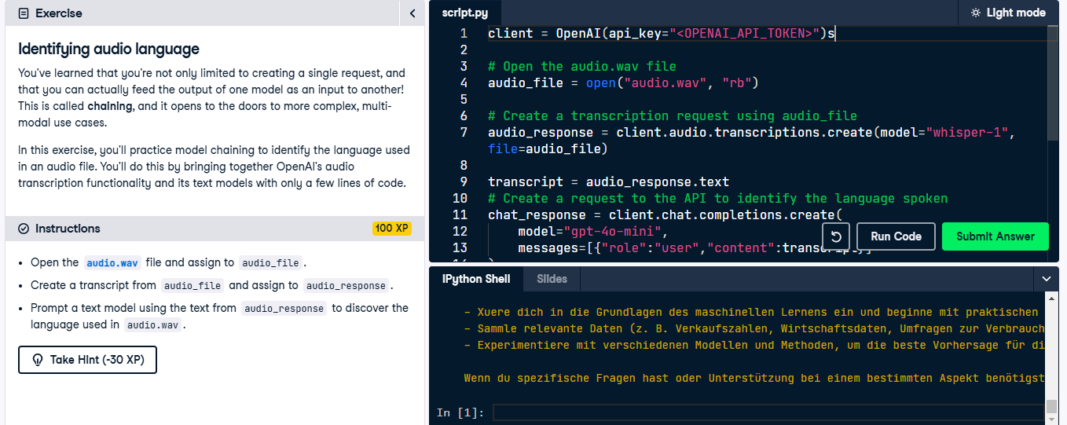

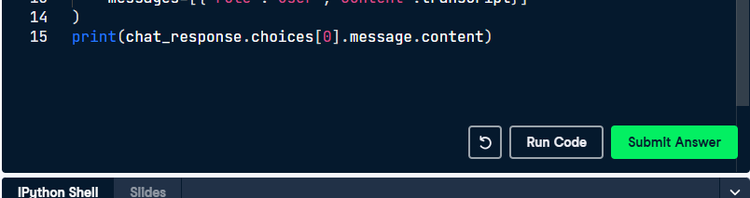

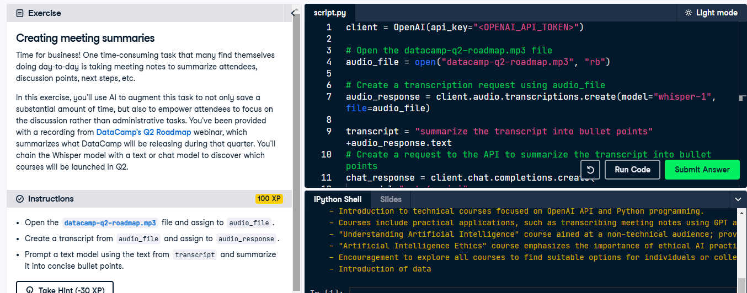

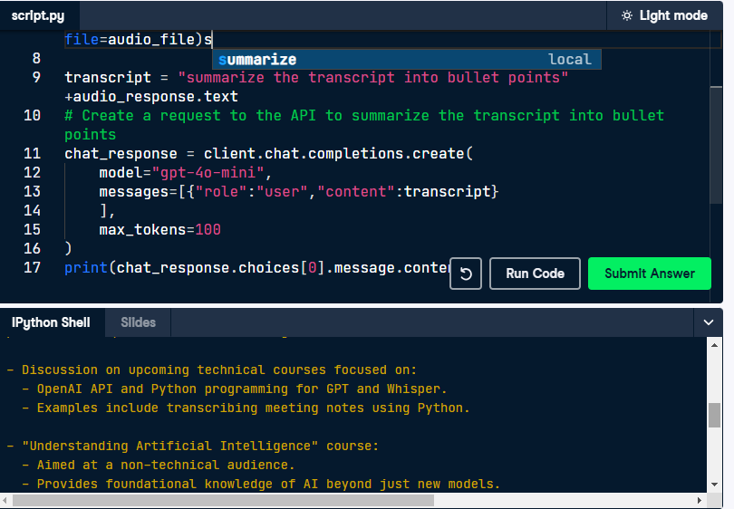

**Congratulations!**

**WORKING WITH THE OPENAI API**

## James Chapman

Curriculum Manager, DataCamp

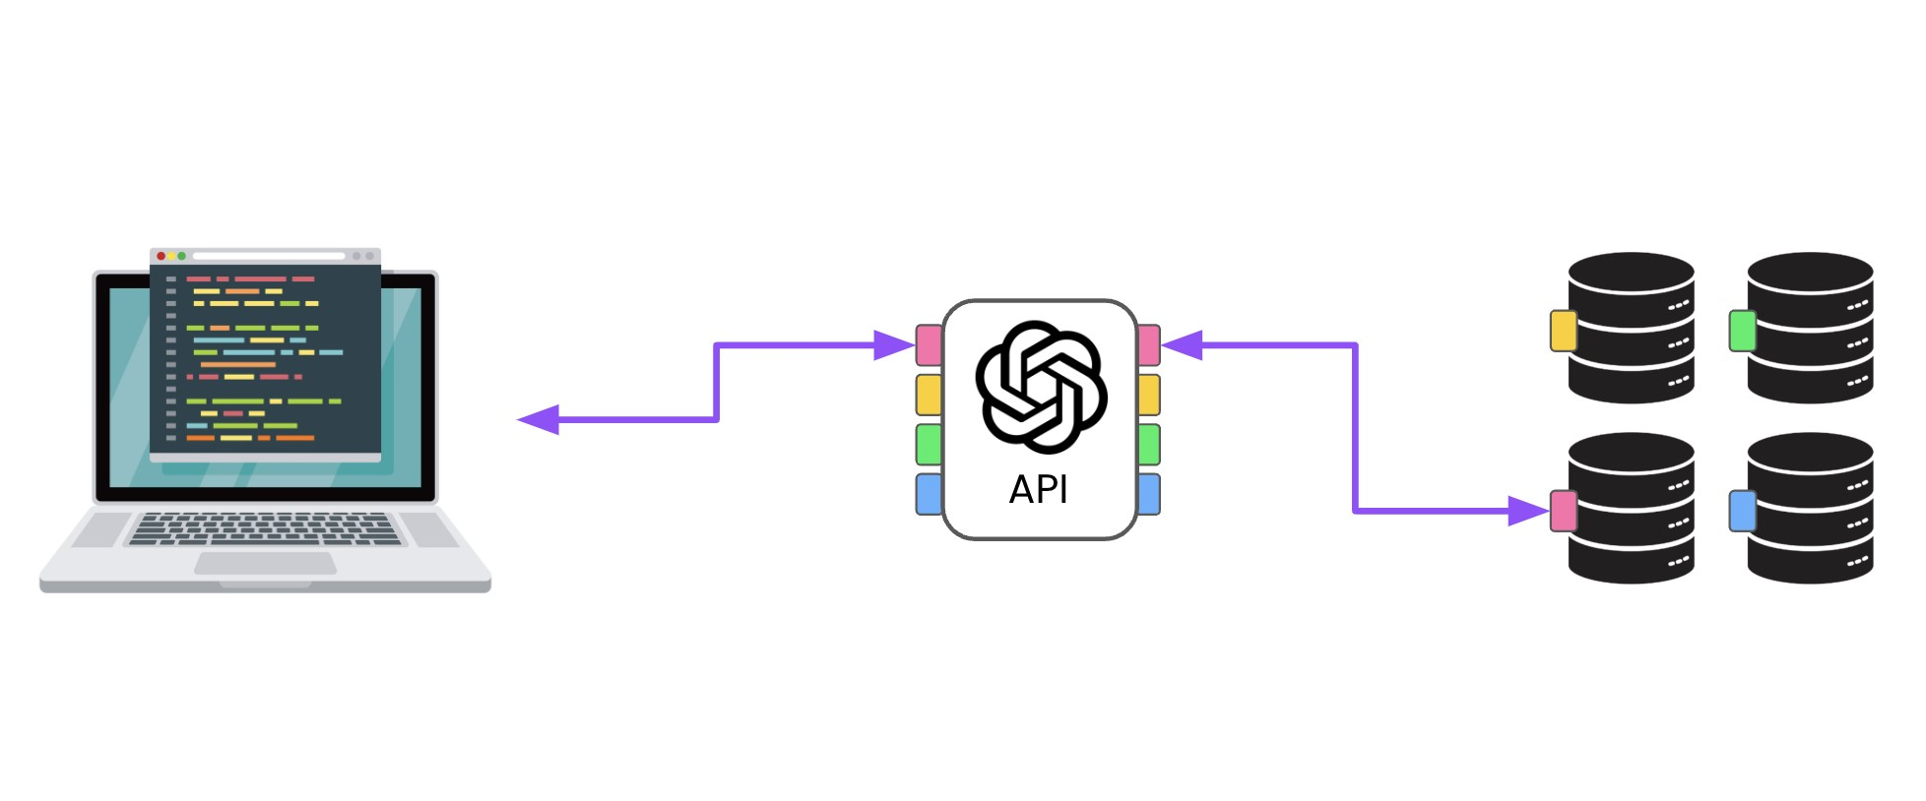

What the OpenAI API is used for

How to create requests to the Chat

Completions endpoint

client = OpenAI(api_key="<OPENAI_API_TOKEN>")

response = client.chat.completions.create( model="gpt-4o-mini",

messages=[{"role": "user", "content": "..."}]

) print(response.choices[0].message.content)

response = client.chat.completions.create( Q&A model="gpt-4o-mini",

Text transformation

messages=[{"role": "user", "content": "..."}],

max_tokens=20, Content generation temperature=0.5

) Sentiment analysis



Categorization

max_tokens

and

temperature

Multi-turn conversation with chat

r

o

l

e

s

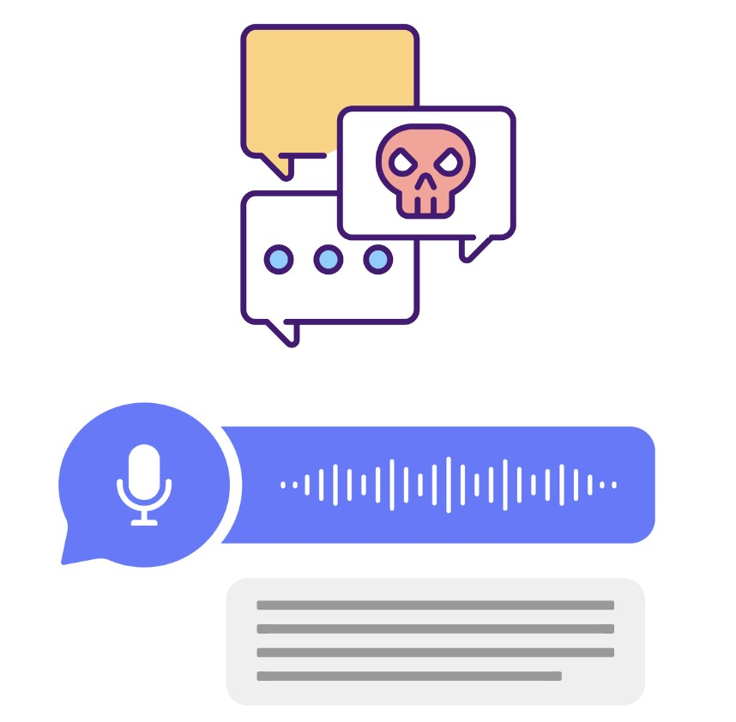

**Moderation**

Detect inappropriate content **Audio**

Translate

Transcribe **Chaining**

Automating complex tasks

**What next?**

AI application development:

[**OpenAI Fundamentals**](https://www.datacamp.com/tracks/openai-fundamentals) skill track

[**Developing AI Applications**](https://www.datacamp.com/tracks/developing-ai-applications) skill track

[**Associate AI Engineer for Developers**](https://www.datacamp.com/tracks/associate-ai-engineer-for-developers) career track

Apply your learning in projects:

[**Planning a Trip to Paris with the OpenAI API**](https://app.datacamp.com/learn/projects/1849)

[**Enriching Stock Market Data using the OpenAI API**](https://app.datacamp.com/learn/projects/1896)

**Let's practice!**

**WORKING WITH THE OPENAI API**